Transport Management
P.K.Akshay¹, M.Ajay²,M.Akash³, Gladwin A⁴
BTech, IT. ,Jeppiaar Engineering College, Chennai, India ¹
BTech, IT. ,Jeppiaar Engineering College, Chennai, India ²
BTech, IT. ,Jeppiaar Engineering College, Chennai, India ³
Assistant Professor, Jeppiaar Engineering College, Chennai, India ⁴

ABSTRACT: The changes in routes daily provide an overhead when it comes to paper usage and the combined routes on some days are really difficult to handle because of the increase in number of students in our college.This application takes in variable inputs for the departure time when it comes to regular college days and exam times when the topic of combined routes based on the number of students is discussed.The solution to the above problems are given through this applcation where it is embedded along with the student database to retreive the list of students from a particular boarding point so that the drivers get to know the exact strength of students too.

Keywords: J2EE,Spring Boot,Spring MVC,Maven Project.

I.INTRODUCTION
This system has many advantages and in today's world everything is going at a fast pace and we need new tools and techniques to resolve our day to day problems that we face. Our initiative is also to go on and provide solutions to tough problems by the design and use of automated tools that could do our work within few minutes. The issue of continuously changing bus routes have made so many students be in different minds as to whether to choose one route or the other. This application solves that problem and goes on to describe as to how a student can choose a bus route given a number of routes or even search for and look for a particular location where he desires to go to. The bus routes are totally 42 in number and are changing constantly everyday based on the number of students who arrive in the morning. The combined bus routes which are assigned at the time the bus departs back home is a headache for many students.
II.SYSTEM MODEL AND ASSUMPTIONS
This system has been divided into two distinct layers of execution. The first layer being the user layer where in the user would be able to look at all the routes for the particular day and along with the strength in the number of students who are supposed to be in that particular route for the day. The user can also go on and choose a particular route of his choice if he feels that he would like to get down at a different point rather than his prescribed boarding point. Yet another feature of this application is that the user can also search for a particular drop point of intermediate point and select that point as his stop point. This application brings in abstraction when it comes to the layering in the sense , the user will not be able to add, modify or delete a route as that has been given as the job of the admin of the system. The second layer of execution is that of the admin wherein , he would be given credentials that are hash coded into the database and once he logs into the application , he would be able to modify any of the routes for that particular day. To ensure that no one else uses this system we have provided the first layer of abstraction being the login screen. Once the admin has logged into the system he will be able to add a route, modify a route as well as delete a route. The assumptions for this system is that the number of students who come to college on a regular basis are around 3000 in number. The number of buses scheduled for those students are 42 in number. The timings of the bus departure from the college being 3:15PM and 5PM . There are totally 8 intermediate points in between college and the boarding points.
III.EFFICIENT COMMUNICATION
The architecture followed by this system is based on the Spring MVC pattern which defines certain rules to be followed when the application has to be deployed. Since it follows the MVC pattern which is described as model , view , controller , the security and the deployment of this application becomes rather easy. It follows a client server model therein being able to provide accurate information to the clients on a regular basis , say intervals of 5-10 seconds as the user page is being refreshed and coordinating with the server for the information. The application is a derivable of Spring Boot which the latest trend in the market which provides many advantages such as dependency injection , easy dependency management of the maven project team etc. When the routes in the college are changing daily the people who take care of this before the system is deployed used papers and ink to display the route day after day which actually lead to wastage of paper and ink and they also used to calculate the strength of the number of students who would be in college for that particular day and then schedule the buses. This had a huge overhead over the communication aspect as they had to ask staffs in many domains for this information. The system which is being deployed takes care of this problem and goes on to solve it by providing the right information from the number of students to the routes for the day and the intermediary points to be precise which the admin provides.
IV.SECURITY
This application cannot be broken as there are some security measures which are deployed to ensure that no one gets hold of this application or creates a fake one to present to the user. The possible ways to attack this system would be :
1. URL Attack : This attack can be defined as the method of accessing the applications URL through the console of the web browser that the attacker is using. Once the attacker gets a hold of the URLs used in the application , he could go on to create a fake application with the same URLs and present it with the same design as that of the former , hence creating an similar look alike of the system to the user.
2. Password Attack : This attack is on the admin side of the application wherein the attacker tries to get to know the password of the admin so that he could go on and change routes based on his on decision which would affect the stakeholders of the system with pretentious data.

These two attacks are prevented by the efficient use of security mechanisms that are in place to prevent them before they happen. For the URL attack , each and every URL in the application on the server side has been encrypted so that the attacker will have no clue as to what the URLs of the system are and will not be able to extract the data from the URLs from the browsers local storage.
The second attack for the password , there is a security mechanism in place that ensures that the password of the system has been hash-coded into the database so that no one finds out the password even if the database is compromised. As for the front end the password will not be shown on console as it is being hashed once the user logs in.
The abstraction concept is one other way of ensuring security for the system , it is by dividing the system into many layers so that each layer is for its own intended user and serves its purpose and is not accessed by any other person other than that intended user. It is achieved through the concept of session handling and providing certain roles for certain users.

V. RESULT AND DISCUSSION

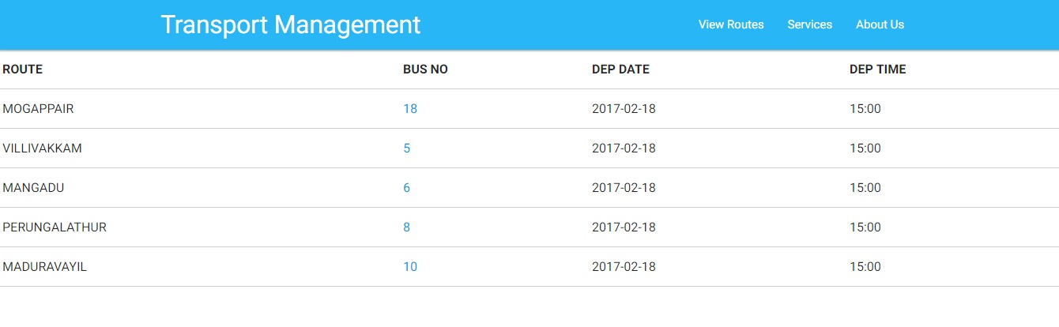
fig 2 :View Routes functionality for the user
In the Fig 2 , it describes the "View Routes" functionality for the user with the tooltip bootstrap plugin for the intermediary points to be viewed on hover of every bus number.

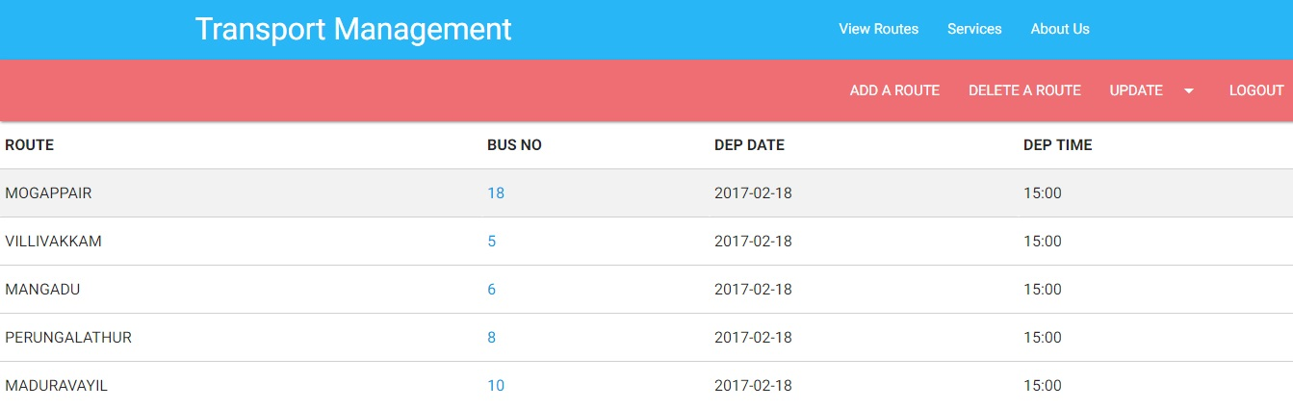
Fig .3 The admin page to manipulate the routes.
In Fig 3, it describes the admin page functionalities with drop down for updating a route details with respective inputs such as bus number , intermediate points and route name. Session handling is done for the admin login functionality to provide abstraction when it comes to admin and the student user.
VI.CONCLUSION
The problem statement being that students and staffs were getting trapped in the stampaid on the cource of finding there dialy routes in the system students were not able to decide upon which route to take daily back to their respective boarding points and the second main problem being that the college officials were in dual mind as to whether to send the entire 42 buses of just a needful of buses as the student strength decreases for the day. Using this system they will be able to decide upon which routes to allocate and de-allocate for that day and in turn also get the number of students for that particular route for combined routes. This system is efficient in terms of communication , cost for the college and provides a solution for wasting a lot of paper and ink to display the routes to the students and staffs.
- References

- "Bus Management System based on Zigbee and GSM/GPRS" by L.V.Zhian , Hu-Han.
- Spring Boot Documentation , https://docs.spring.io/spring-boot/docs/current-SNAPSHOT/reference/htmlsingle/
- Spring Web MVC Documentation , https://docs.spring.io/spring/docs/current/spring-framework-reference/html/mvc.html
- Front End Design , Bootstrap Documentation , http://getbootstrap.com/getting-started/
- Programming Tutorials , https://www.w3schools.com/html/
- MySql Server 5.7 Reference Docs , https://dev.mysql.com/doc/refman/5.7/en/
- Hibernate Documentation – https://docs.jboss.org>orm>html_single
- GPS based Bus Management System – Slide Share https://www.slideshare.net>neerajatulankit .

